Test Activities and Test Roles

1-Test Activities
# Source: AI Source: Provided by: [Data Path: Persons Table -> ID Column: 1, Name_En Column: Motasem Essam] -> From: [ChatGPT] on [8/21/2025]
Test Activities are the main steps in the software testing process — they describe what testers do from start to finish.
Here’s the standard sequence (from ISTQB testing process):

1-Test Activities Types

1. Test Planning 📝
# Source: AI Source: Provided by: [Data Path: Persons Table -> ID Column: 1, Name_En Column: Motasem Essam] -> From: [ChatGPT] on [8/21/2025]
- Define the scope, objectives, strategy, resources, schedule, and risks.
- Decide what to test, how to test, and when to stop testing (exit criteria).

2. Test Monitoring and Control 📊
# Source: AI Source: Provided by: [Data Path: Persons Table -> ID Column: 1, Name_En Column: Motasem Essam] -> From: [ChatGPT] on [8/21/2025]
- Monitoring: Track test progress (e.g., how many tests passed/failed).
- Control: Adjust the plan if things go off track (e.g., change priorities, add more testers).

3. Test Analysis 🔍
# Source: AI Source: Provided by: [Data Path: Persons Table -> ID Column: 1, Name_En Column: Motasem Essam] -> From: [ChatGPT] on [8/21/2025]
- Review requirements, design, and other documents to find test conditions.
- Example: From “Users must be able to reset password” → create test condition: "Verify password reset process works via email link."

4. Test Design 🛠
# Source: AI Source: Provided by: [Data Path: Persons Table -> ID Column: 1, Name_En Column: Motasem Essam] -> From: [ChatGPT] on [8/21/2025]
- Convert test conditions into test cases, test data, and expected results.
- Decide which tools/scripts you’ll use.

5. Test Implementation ⚙
# Source: AI Source: Provided by: [Data Path: Persons Table -> ID Column: 1, Name_En Column: Motasem Essam] -> From: [ChatGPT] on [8/21/2025]
- Prepare test suites, configure test environments, load test data.
- Link test cases to requirements.

6. Test Execution ▶
# Source: AI Source: Provided by: [Data Path: Persons Table -> ID Column: 1, Name_En Column: Motasem Essam] -> From: [ChatGPT] on [8/21/2025]
- Run the tests, compare actual vs. expected results.
- Report any defects found.

7. Test Completion ✅
# Source: AI Source: Provided by: [Data Path: Persons Table -> ID Column: 1, Name_En Column: Motasem Essam] -> From: [ChatGPT] on [8/21/2025]
- Check if exit criteria are met.
- Write test summary reports, archive test artifacts, and analyze lessons learned.

💡 In short:
Plan → Monitor/Control → Analyze → Design → Implement → Execute → Complete

Example of Test Activities
# Source: AI Source: Provided by: [Data Path: Persons Table -> ID Column: 1, Name_En Column: Motasem Essam] -> From: [ChatGPT] on [8/21/2025]
Alright — here’s an example of Test Activities mapped to a real project so it’s easier to imagine.

Scenario:
# Source: AI Source: Provided by: [Data Path: Persons Table -> ID Column: 1, Name_En Column: Motasem Essam] -> From: [ChatGPT] on [8/21/2025]
You’re testing an online food delivery app like Talabat or Uber Eats.

1. Test Planning 📝
# Source: AI Source: Provided by: [Data Path: Persons Table -> ID Column: 1, Name_En Column: Motasem Essam] -> From: [ChatGPT] on [8/21/2025]
- Decide to test user login, restaurant search, cart checkout.
- Risk: Payment failures could impact revenue, so payment is high priority.
- Exit criteria: 100% of critical tests must pass, ≤ 2 minor UI bugs allowed.

2. Test Monitoring & Control 📊
# Source: AI Source: Provided by: [Data Path: Persons Table -> ID Column: 1, Name_En Column: Motasem Essam] -> From: [ChatGPT] on [8/21/2025]
- Daily track: “20% of test cases executed, 5 defects found, 2 fixed.”
- If login testing is delayed → shift one tester from search testing to login.

3. Test Analysis 🔍
# Source: AI Source: Provided by: [Data Path: Persons Table -> ID Column: 1, Name_En Column: Motasem Essam] -> From: [ChatGPT] on [8/21/2025]
- From requirement: “User can pay with credit card or cash.”
- Test conditions:
  - Payment via valid credit card succeeds
  - Payment via expired card fails
  - Payment via cash option succeeds

4. Test Design 🛠
# Source: AI Source: Provided by: [Data Path: Persons Table -> ID Column: 1, Name_En Column: Motasem Essam] -> From: [ChatGPT] on [8/21/2025]
- Test case example:
ID: PAY-01
Step: Select credit card → enter valid card → confirm payment
Expected Result: Payment success message shown

5. Test Implementation ⚙
# Source: AI Source: Provided by: [Data Path: Persons Table -> ID Column: 1, Name_En Column: Motasem Essam] -> From: [ChatGPT] on [8/21/2025]
- Upload test cases into a tool like Jira/Xray or TestRail.
- Prepare test environment with test payment gateway and sample restaurant data.

6. Test Execution ▶
# Source: AI Source: Provided by: [Data Path: Persons Table -> ID Column: 1, Name_En Column: Motasem Essam] -> From: [ChatGPT] on [8/21/2025]
- Run test case PAY-01 → Actual: Payment success. PASS
- Run PAY-02 (expired card) → Actual: App crashes. FAIL → Defect logged

7. Test Completion ✅
# Source: AI Source: Provided by: [Data Path: Persons Table -> ID Column: 1, Name_En Column: Motasem Essam] -> From: [ChatGPT] on [8/21/2025]
- Exit criteria met: All critical tests passed after fixes.
- Defect summary: 12 bugs found, 12 fixed.
- Lessons learned: Need earlier environment setup to avoid delays.

This way, you can see the testing process is not just clicking buttons — it’s planned, tracked, and reported.

Summary
# Source: AI Source: Provided by: [Data Path: Persons Table -> ID Column: 1, Name_En Column: Motasem Essam] -> From: [ChatGPT] on [8/21/2025]
(Based on standards like ISTQB)
- Test Planning 🗓️
  - Define the scope, objectives, approach, resources, schedule, and risks of testing.
  - Example: Decide what features to test, who will test them, and what tools to use.
- Test Analysis 🔍
  - Study requirements and identify what needs to be tested.
  - Example: From a login requirement, identify that username, password, and error handling need tests.
- Test Design ✏️
  - Create detailed test cases and test data to cover identified requirements.
  - Example: Write a test case for “Login with incorrect password shows error message.”
- Test Implementation ⚙️
  - Prepare test environment, finalize test cases, and set up automation if needed.
  - Example: Configure staging server and load test scripts into a testing tool.
- Test Execution ▶️
  - Run the tests and record the results (pass/fail).
  - Example: Execute login test cases and note that 3 passed, 1 failed.
- Test Completion & Closure 📄
  - Summarize results, evaluate exit criteria, document lessons learned, and archive testware.
  - Example: Write a final test report and mark testing as complete.

2-Test Roles
# Source: AI Source: Provided by: [Data Path: Persons Table -> ID Column: 1, Name_En Column: Motasem Essam] -> From: [ChatGPT] on [8/21/2025]
Test Roles are the different responsibilities and positions people take on within the software testing process to make sure testing is planned, executed, and reported effectively.
It’s basically “who does what” in testing.

Common Test Roles
# Source: AI Source: Provided by: [Data Path: Persons Table -> ID Column: 1, Name_En Column: Motasem Essam] -> From: [ChatGPT] on [8/21/2025]
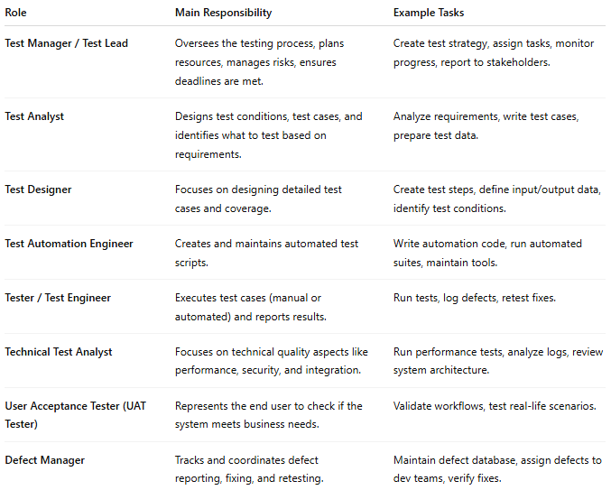
Role | Main Responsibility | Example Tasks
Test Manager / Test Lead | Oversees the testing process, plans resources, manages risks, ensures deadlines are met. | Create test strategy, assign tasks, monitor progress, report to stakeholders.
Test Analyst | Designs test conditions, test cases, and identifies what to test based on requirements. | Analyze requirements, write test cases, prepare test data.
Test Designer | Focuses on designing detailed test cases and coverage. | Create test steps, define input/output data, identify test conditions.
Test Automation Engineer | Creates and maintains automated test scripts. | Write automation code, run automated suites, maintain tools.
Tester / Test Engineer | Executes test cases (manual or automated) and reports results. | Run tests, log defects, retest fixes.
Technical Test Analyst | Focuses on technical quality aspects like performance, security, and integration. | Run performance tests, analyze logs, review system architecture.
User Acceptance Tester (UAT Tester) | Represents the end user to check if the system meets business needs. | Validate workflows, test real-life scenarios.
Defect Manager | Tracks and coordinates defect reporting, fixing, and retesting. | Maintain defect database, assign defects to dev teams, verify fixes.

Example
# Source: AI Source: Provided by: [Data Path: Persons Table -> ID Column: 1, Name_En Column: Motasem Essam] -> From: [ChatGPT] on [8/21/2025]
Imagine you’re testing an e-commerce site:
- Test Manager: Decides testing scope and resources.
- Test Analyst: Reads the requirements and says “We must test checkout, login, and search.”
- Tester: Executes those tests.
- Automation Engineer: Writes Selenium scripts to test checkout automatically.
- UAT Tester: Pretends to be a customer and tries buying something.

